- (a) Draw a scatter graph for the information below, about computers:

Cost of computer in pounds | 130 | 320 | 470 | 240 | 180 | 290 | 360 | 190
Average lifespan of computer in months | 2 | 15 | 20 | 5 | 4 | 10 | 15 | 5

(b) Add on a line of best fit
(c) Using your graph, estimate the lifespan of a computer costing £200.

- 16 people were asked to name their favourite drink.
Coffee | Irn Bru | Coffee | Coke
Tea | Irn Bru | Tea | Coke
Coke | Tea | Coffee | Tea
Irn Bru | Coke | Coffee | Coke

- Draw a frequency table for this information:
- Draw a bar chart to show the data.
- Which is the most popular drink?
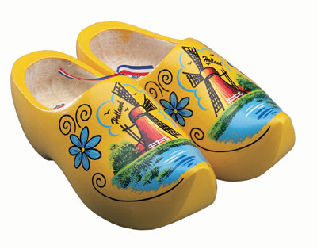
- These are the shoe sizes for ten people in Holland:

8 | 10 | 5 | 11 | 10 | 9 | 8 | 12 | 7 | 9

- Find the maximum and minimum.
- Find the range.
- Find the mean.

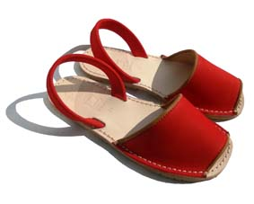
These are the shoe sizes for ten people in Spain:

4 | 5 | 9 | 3 | 6 | 8 | 7 | 9 | 8 | 5

- Find the maximum and minimum.
- Find the range.
- Find the mean.

- Based on your results, are the shoes sizes bigger in Holland or Spain?

- (a) Draw a scatter graph for the information below, about pages in a book and price:

Number of Pages | 159 | 215 | 340 | 115 | 75 | 260 | 380 | 100
Price | £6 | £15 | £40 | £10 | £5 | £25 | £30 | £15

(b) Add on a line of best fit
(c) Using your graph, estimate the price of a book with 200 pages in it.
(d) Using your graph, estimate the number of pages in a book that costs £30.

- 16 people were asked to name their favourite Super Hero.
Incredible Hulk | Spider Man | Incredible Hulk | Batman
Captain America | Batman | Spider Man | Captain America
Incredible Hulk | Batman | Captain America | Batman
Captain America | Spider Man | Captain America | Incredible Hulk

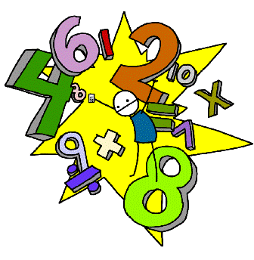
- Draw a frequency table for this information:
- Draw a bar chart to show the data.
- Whois the most popular Super Hero?

- These are test scores (out of 20) for ten people in Maths:

2 | 7 | 18 | 16 | 13 | 18 | 10 | 17 | 15 | 4

- Find the maximum and minimum.
- Find the range.

- Find the mean.

These are the test scores (out of 20) for ten people in French:

12 | 14 | 9 | 19 | 16 | 15 | 9 | 7 | 22 | 6

- Find the maximum and minimum.
- Find the range.
- Find the mean.

- Based on your results, were the test scores higher in Maths or French?

