N4 Applications of Maths - Geometry and Measure Practice Assessment 2
1 Richard is cooking a 3 kg joint of beef for a dinner party. The formula for calculating the cooking time is:
T = 20w + 25
w = weight in kg T = time in minutes
(a) How long, in hours and minutes, will it take for the beef to cook

(b) The beef must be cooked by 1720 hours. At what time should he put the beef in the oven?

2 A sailing club is planning a competition route as shown below:
From the start:
sail 35 km on a bearing of 040° to Mark 1
then
sail 45 km on a bearing of 160° to Mark 2
(a) Using the scale ‘1 cm represents 5 km’ make a scale drawing of the route. Use a separate piece of paper and attach it to this booklet.

(b) The boats return directly to the start from Mark 2. How far would the boat need to sail on this section of the route?

3 A sample of six boxes contains the following number of nails per box:
23 29 31 30 29 34
Which of these boxes of nails would be outside a tolerance of 28 ± 2 nails per box?

4 Regulations state that the gradient of ramps for wheelchairs must not exceed 0.3.
An existing ramp is 410 cm long and has a horizontal distance of 400 cm, as shown:
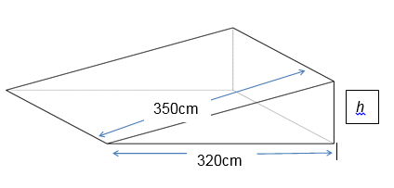
(a) Calculate the vertical height, h.

(b) Does this ramp satisfy the regulations? Give a reason for your answer.

5 The cuboid below has a square base of 6cm and a height of 10cm, as shown.
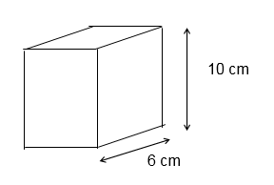

(a) How many cuboids can be filled by an 8 litre jug of water?
(1000 cm³ = 1 litre)

(b) If the volume of the cuboid doubles, how many cuboids can now be filled from the jug of water?

6 Anwar has bought a bookcase to store his books. The bookcase has 5 shelves. Each shelf measures 60 cm long by 15 cm high.
60 cm
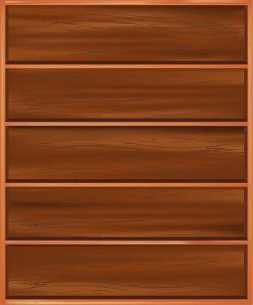
15 cm

He has a collection of books he wants to put into the bookcase.
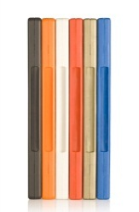
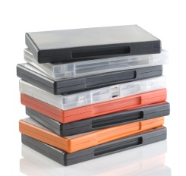
Each book measures 13·5 cm by 15 cm by 1·8 cm (spine width). Anwar can stack them in two different ways:

Vertically
Horizontally

- Work out the maximum number of books he can put in the bookcase:
    - Horizontally

    - Vertically

(b) Explain to Anwar the best way of putting the books in the bookcase so that the maximum number can be stored.

7 Emily plans to paint her bedroom walls.

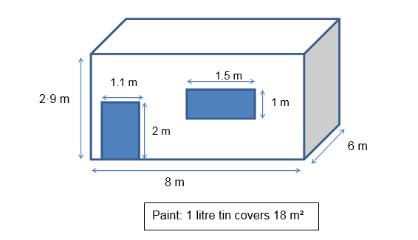
The bedroom is in the shape of a cuboid, with dimensions as shown.

(a) What is the total area of the bedroom walls?

(b) What volume of paint must Emily buy to paint the walls of her bedroom?

(c) How many tins of paint will Emily need to buy?

(d) Paint is sold in 1 litre tins costing £8·50 each. What will be the cost of painting her bedroom?

(e) New skirting boards need to be fitted around the walls of the bedroom at floor level (excluding the door). Calculate the total length of skirting board needed.

