N4 Apps of Maths - AVU Paper 2 Revision |  | O | R
1. | The table below shows the marks scored by eight pupils in a chemistry test and a physics test.  (a) Use these marks to draw a scatter diagram below.  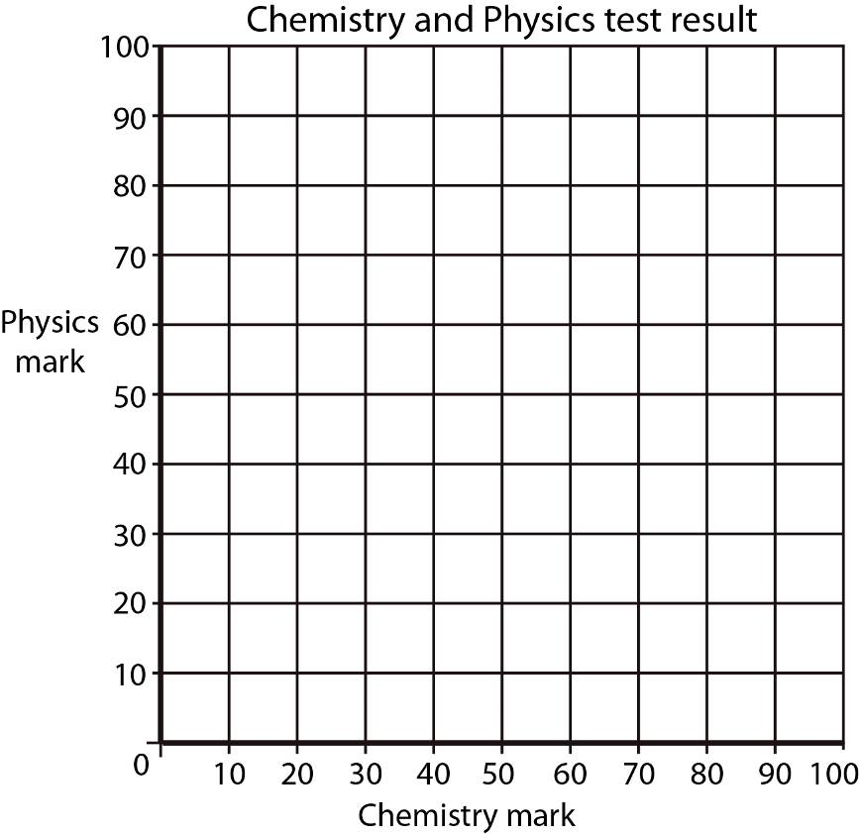  (b) Draw a line of best fit.  (c) Irene scored 40 in her Chemistry test but was absent from the Physics test. Use your line  of best-fit to predict her Physics mark. | 2 | 1  1
  Pupil | A | B | C | D | E | F | G | H
  Chemistry | 24 | 58 | 19 | 87 | 46 | 78 | 43 | 90
  Physics | 29 | 67 | 13 | 78 | 58 | 69 | 65 | 85
 |  | O | R
2. | 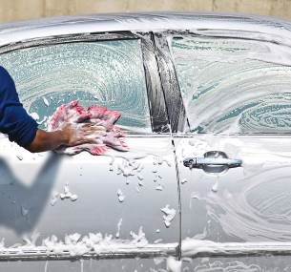  Fourth year pupils at Grangemouth High School are washing cars and selling raffle tickets to raise money for the prom.  - They washed 50 cars at £2·50 each.  - They sold 65 raffle tickets at £1·30 each.  Items bought by the school are shown below:  - Use the above information about income and expenditure to complete the Financial Statement below.  Financial Statement  (b) Overall, did the event raise money for prom?  Give a reason for your answer. | 3 | 1  1
  Expenses
  Sponges | £11·50
  Car washing liquid | £13·50
  Stationery | £3·25
  Prizes | £12·00
  INCOME |  | EXPENDITURE
  Item | Amount (£) | Item | Amount (£)
  Total  Income |  | Total Expenditure
 |  | O | R
3. | Tom works in a supermarket.  His basic pay is £8 per hour.  When he works overtime he is paid time and a half.  (a) Last week Tom worked nine hours overtime.  How much was he paid for this overtime?  (b) Write Tom’s overtime pay in the payslip below.  Complete the payslip by calculating his:  i) Gross pay  ii) Total deductions  iii) Net pay | 1  3 | 1  1
  Payslip
  Name | Employee No. | Week | NI Number
  Tom | 00341 | 12 | QP28942C
  Basic Pay | Overtime Pay | Bonus | Gross Pay
  £240 |  | £70
  National Insurance | Income Tax | Pension | Total Deductions
  £21·66 | £32·99 | £0·00
   |  |  | Net Pay
 |  | O | R
4. | Aamir decides to wallpaper his room.  4·6 m  2·6 m  2·4 m  Skirting board 0·18 m  The dimensions of his room are:  - Height 2·6 metres  - Length 4·6 metres  - Breadth 2·4metres  - Measurement around the room 14 metres  A skirting board, 0·18 metres high, goes around the bottom edge of the walls excluding the door.  To calculate how many rolls of wallpaper he will need, he uses the information below.  (a) Calculate the height of the wall from the top of the skirting board to the ceiling in metres.  - Use the information in the table to calculate how many rolls of wallpaper Aamir should buy. | 1 | 1
 |  | O | R
5. | Fiona and Jackie are going to France on holiday.  They both have £700 to change to euros.  Fiona changes her £700 at a travel agent and she receives 600 euros.  Jackie changes her £700 online with eurox.co.uk. Eurox.co.uk charge Jackie a fee of £12 and then change the rest at a rate of  £1 = 1·24 euros.  (a) Calculate how many euros Jackie gets from eurox.co.uk.  (b) Give a reason why Fiona gets more euros than Jackie. | 1 | 2  1
 |  | O | R
6. | Sixteen passengers have arrived at the airport and are waiting to go to their hotel.  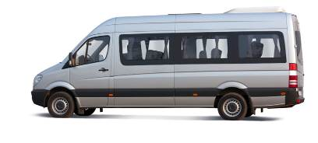  The hotel has a minibus which can take all of the passengers and their luggage to the hotel from the airport.  The trip takes:  - How much time does it take all of the passengers to get on the minibus, travel to the  hotel and then get off the minibus with their luggage?  - The minibus arrives at the airport to pick up the passengers at 23:40.  Using the timing in (a), what time would you expect the last passenger to leave the minibus with their luggage? | 1 | 1
  13 minutes | For all of the passengers to get on the minibus with their luggage
  40 minutes | Between the airport and the hotel
  16 minutes | For all of the passengers to get off the minibus with their luggage
 |  | O | R
7. | Lettini Family Budget in May  Sinclair Family Budget in May  Food  28%  Rent  20%  Clothes 18%  Other Items  14%  Car  5%  Savings 15%  Food  33%  Rent  25%  Clothes 14%  Other Items  20%  Buses  8%  The diagram above shows the percentage of income that the Sinclair family and the Lettini family spent on various items in the month of May.  (a) The Sinclair family spent £525 on rent.  Calculate their total income in May.  (b) The Lettinis’ total income in May was £1650.  Which family spent more on food and by how much? | 1  2 | 1  1
 |  | O | R
8. | Mr Smith is replacing the carpet in his office.  The dimensions of the carpet are given on the diagram.  9·4 m  7 m  15·8 m  Calculate the area of the carpet. | 1 | 2

