Assessment tasks

4. Complete the following table which shows departure and arrival times for different bus journeys.

$$\frac{}{3}$$

Depart  $$\frac{}{3}$$ | Arrive | Time taken
0945 | 1355
2010 |  | 7h 35 mins
 | 1605 | 2h 35 mins

5. The diagram shows an L-shaped room.
4 metres

8 metres

2 metres
O1.5

$$\frac{}{1}$$

$$\frac{}{1}$$

8 metres

The joiner finishing the room bought 27m of wood for the skirting.

Has he bought enough wood to edge the whole room?

6. A cyclist travelled a speed of 12mph for 15 minutes.

$$\frac{}{1}$$

How far does he travel in this time?

7. The PT decides his 54 textbooks should be split in the ratio of 4:5 between two classes.

The larger class received 28 books.

$$\frac{}{2}$$

O1.5

$$\frac{}{1}$$

Is this the correct amount?
Justify your answer by calculation.

13. A school survey asked 768 pupils their favourite sports. The results are shown in the pie chart below:
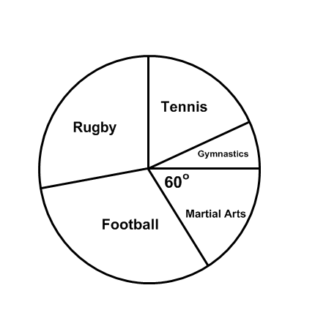
105°

How many pupils favourite sport was Rugby?

$$\frac{}{1}$$

$$\frac{}{1}$$

O2.1

14. An investment company promises a different rate of profit depending on which product you choose and how much money you invest.

Product | Less than £500 | Between £500 and £1000 | Between £1000 and £10000 | More than £10000
ISA | 2.1% | 2.3% | 2.4% | 3.8%
Bonds | 1.7% | 2.5% | 2.6% | 3.5%  O2.1
Shares | 2.4% | 2.2% | 2.8% | 3.1%  $$\frac{}{1}$$

If you invest £10950 which product will give you the most profit?

15. A local pet shop gathered the data from birth of animals requiring a haircut.
The compound bar chart below gives the results of the data collected.
(a) How many dogs needed a haircut in the 3rd year?

(b) Compare the numbers requiring a haircut by both cats and dogs across the 4 years.

16. Three mobile phone companies each have a contract available at the same price.

 | Company A | Company B | Company C
Calls (minutes) | 300 | 200 | 100
Texts | 200 | 400 | 300  O2.2
Internet (Mb) | 250 | 100 | 750  $$\frac{}{1}$$

John is looking for a mobile phone contract which will give him
250 minutes of calls, 150 texts, and 100Mb of internet use.

Which company’s plan would be best for him?

17. Pupils are being selected to represent the school in a mathematics competition.
O2.3

$$\frac{}{1}$$

Class A has 20 pupils and 3 are to be selected
Class B has 25 pupils and 4 are to be selected

In which class do you have a better chance of being selected?

18. Three rugby teams play in the same city.

Club A has lost 5 of their 15 games
Club B has lost 6 of their 17 games
Club C has lost 2 of their 7 games

$$\frac{}{1}$$

O2.3

Which team has lost the lowest proportion of games played?
Justify your answer by calculation.

