NATIONAL 4 – NUMERACY (Practice)
Answer these questions, showing all working.

1 Denise bought a new car. The price was £9 250 + VAT.

VAT is charged at 20%.
What was the total price?

2 A crate holds 24 cans of tomato soup. The total weight is 6.2kg. If each tin of soup is weighs 250g, what is the weight of the empty crate?

3 James returned from holiday to Florida with $279. He exchanged his dollars back into pounds. How much did he get if the exchange rate was 1.55 dollars to a pound?

4 Carly goes to the cinema to see a film. The film starts at 7.50pm. It lasts for 2 hours and 25 minutes. If the last bus home is at 10.40pm, how long will Carly have to wait for the bus?

5 Farmer Bob decided to join two rectangular fields together to allow
his cattle to have more room to graze. He bought fencing to go
around the outside of the fields as shown in the diagram below.
12m

12m

26m

30m

Farmer Bob bought 115m of fencing.

Is the fencing long enough for the area?
Justify your answer by calculation.
6 In the London 2012 Olympics Usain Bolt ran at a speed of 10·35 m/s.
If he could run for a whole minute at this speed, how far would he have travelled?

7 A lottery winner decides to donate £765 000 to two of his favourite charities. He decides to split the donation in the ratio 4:5, giving the biggest amount to his favourite charity.

His favourite charity need £450 000 to build a new aid centre. Did they receive enough?

Justify your answer.

8 In Dundee, in one cold February day, temperatures dropped from
4°C to –3 °C.

By how many degrees has its temperature dropped?

9 This scale shows speed in miles per hour.
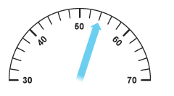

If the speed limit is 50 mph. By how much is the driver breaking
the speed limit?

10 A new laptop is on sale in “Shoppy Shop” for £385. In “Thrifty Shop” the laptop is available for a £50 deposit followed by twelve payments of £29.95.


How much would you save by buying the laptop from “Shoppy
Shop”?
Justify your answer by calculation.

11 The diagram below shows a circle with a sector shaded.
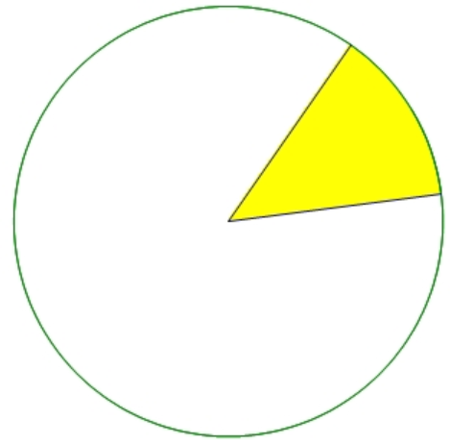

(a) Measure the length of the radius.
(b) Measure the size of the shaded sector angle.

12 A school party are attending the theatre. There are 28 people going and the cost per ticket is £6.50. The theatre have advised the school of a special offer they have.
Buy 4 tickets,
get one ticket free

Using the special offer, how much will it cost for everyone to go?

13 The pie chart below shows how pupils travel to school in Amsterdam.

In a school of 1100 pupils, how many walked to school?
14 The table below shows the cost of travel insurance when travelling within Europe .

Age | Less than 7 days | 7 – 14 days | 15 – 31 days
Less than 16 | £10.50 | £19.50 | £35.00
Between 16 & 40 | £23.00 | £42.00 | £59.00
Between 41 & 60 | £32.00 | £45.00 | £65.00
Over 60 | £45.00 | £75.00 | £98.00

How much would it cost for a 36 year old travelling to France for
3 weeks?

15. The graph shows the amount of rainfall in Dundee over a year.

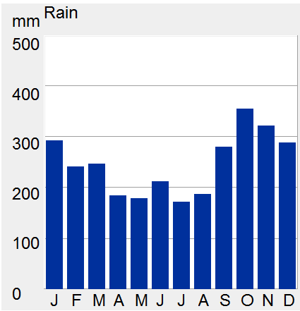
RAINFALL (mm)
MONTH
RAINFALL IN DUNDEE

- Appoximately how much rainfall was there in March?
- Make a comment on the rainfall across the months.

16. Three companies are offering the following deals at the same price.

 | Company A | Company B | Company C
Calls (minutes) | 1000 | 1200 | 1300
TV channels | 330 | 150 | 500
Internet (Mb) | 150 | 300 | 50

Jane is looking for a package to suit her needs. She doesn’t watch much TV, but uses the internet a lot and also makes a lot of calls.

Which company’s plan would be best for her?

17 Two school classes buy raffle tickets for Comic Relief.

The tickets are chosen at random.

Class A has 24 pupils and 3 tickets win.
Class B has 27 pupils and 4 tickets win.

In which class does any one person have a better chance of winning.

Justify your answer by calculation.

18 Three friends are in a badminton club.

Ricky has won 5 out of his 6 games.
Matt has won 10 out of his 13 games.
Paul has won 7 out of his 8 games.

Which person has the best winning record?
Justify your answer by calculation.

National 4: Numeracy Version 2 Marking Scheme

Points for Assessment Standard 1.2 are marked with a bullet in the table.
Points for Assessment Standards 1.3 to 2.3 are marked # in the table.

 | Assessment Standard covered
 | 1.2 | Response | 1.1 | 1.3 | 1.4 | 1.5 | 2.1 | 2.2 | 2.3
1 | Percentage calculation  Addition | - 20% of 9250 = £1850  - £11100 | money
2 | Multiplication  Subtraction | - (24 × 250) = 6000g  - 6200 – 6000 = 200 g | measure
3 | Division | - 279 ÷ 1.55 = £180 | money
4 | Addition  Subtraction | - 7.50pm + 2h 25m  - 10.15pm  - 25 minutes | time
5 | Perimeter calculation | - P = 112 m  #Yes, 115 m > 112 m | measure |  |  | #
6 | Multiplication | - 10.35 × 60  = 621 metres | time
7 | Ratio/ proportion Ratio/ proportion | - 765000/9 = 85000  - 85000 × 5 = £425000  # No, £25 000 short | money |  |  | #
8 | Difference | - 7 degrees | measure
9 | - | #4 mph | measure |  | #
10 | Decimal multiplication | - 409.40  - 409.40-385  # £24.40 is saved | money |  | #
11 | -  - | #Length measure (nearest 0.1cm)  #Angle measure (± 2° ) | measure | #  #
12 | Decimal multiplication | # 5 special offer and 3 tickets  - 23 × £6.50 = £149.50 | money |  | #
13 | Percentage | #15% of 1100  - 165 | number |  |  |  | #
14 | Reading Tables | # £59 | - |  |  |  | #
15 | - | # 250+/- 10  # Reasonable comment relating to more rain in winter months. | - |  |  |  | # (a) | # (b)
16 | - | # Company B is most suitable | - |  |  |  |  | #
17 | Fractions/decimals | #Class B  Evidence of 3/24 = 0.125 and  4/27 = 0·148 (or equivalent) | - |  |  |  |  |  | #
18 | Fractions/decimals | # Paul  Evidence of 5/6 = 0·833, 10/13 = 0.77  7/8 = 0·875 (or equivalent) | - |  |  |  |  |  | #

Tasks | Assessment Standards
Tasks | 1.1 |  |  | 1.2 |  |  |  | 1.3 | 1.4 | 1.5 | 2.1 | 2.2 | 2.3
 | Money | Time | Meas. | Whole Numbers | Fractions | Decimal fractions and  whole number percentages | Ratio and proportion
1.
2.
3.
4.
5.
6.
7.
8.
9.
10.
11. (a)
11. (b)
12.
13.
14.
15. (a)
15. (b)
16.
17.
18.
Required to meet the relevant Assess Standard | 1/5 | 1/2 | 1/4 | The candidate has carried out calculations correctly in at least half of the opportunities. |  |  |  | 1/2 | 1/3 | 1/2 | 1/3 | 1/2 | 1/2
Assessment Standard met ()

