National 4 Expressions and Formulae – Practice

Answer these questions
Outcome 1.1
1 (a) Expand the brackets:
3(5x – 1).

(b) Expand the brackets and simplify:
4(6q+2) + 3q.

2 Factorise 4y + 24.

3 Simplify 6w + 3s + 2w – 2s.

4 (a) When x = 4 and y = 3, find the value of 5x – 4y.

(b) Sally works for in a factory.
Her weekly pay is calculated using the formula:
P = 5.5H + 2.5M
where P is her pay (in pounds), $H$H is the hours she works, and
M is the number of machines she makes.
One week she works 20 hours and makes 16 machines.
Calculate her pay for that week.

(c) One week Sally made 30 repairs and earned £240.
Calculate how many hours she worked that week.

5 The diagrams below show a sequence of shapes (S) made up from bars (B)

Shape 1 Shape 2

Complete the table below.

Number of shapes (S) | 1 | 2 | 3 | 4 | 5 |  | 12
Number of bars (B) | 4 | 7

(b) Write down a formula for calculating the number of bars (B) when you know the number of shapes (S).

6 John is planning a new a new ramp.
His plan of the slope is shown below.

28 cm

57 cm

Calculate the gradient of the slope.

Outcome 1.2
7 The diagram shows a hula hoop.
The hula hoop is a circle with a diameter of 51 cm, as shown below.

51 cm

(a) Calculate the circumference of the hula hoop.
(b) Calculate the area enclosed by the hula hoop.
(c) How many of these hula hoops can be made from 10 metres of
plastic?
8 The design of a sign is in the shape of a parallelogram.

Maths Inc.
The sign has dimensions shown below.

1.3m

2.4m

Calculate the area of the sign.

9 A new TV is sold in a box the shape of a cuboid.
The cuboid is 180 centimetres long, 25 centimetres wide and 90 centimetres high, as shown in the diagram below.

90 cm

25 cm
180 cm

Find the surface area of the cuboid shown.

10 A company has a large container in the shape of a triangular prism.
The area of the base of the container is 13 square metres.
The height of the container is 26.7 metres.

13 m²
26.7 m

Calculate the volume of the container.

11 Jeremy’s Cake Shop wants a new design for the window.
Part of the design for the window is shown below.
Complete this shape so that it has rotational symmetry of order 2, about 0.
O

Outcome 1.3
12 The speed of motorist on A90 was recorded during a 20 minute period.
The results are shown below.
37 | 64 | 57 | 62 | 41 | 46 | 78
48 | 73 | 62 | 64 | 56 | 61 | 75

- Complete the frequency table for these results.

Score | Tally | Frequency
30 – 39
 |  | Total =

- Comment on these results.

13 The ages of eight people were recorded.
Each person’s age was recorded and the results are shown below.
17 | 15 | 35 | 29
25 | 24 | 21 | 16

(a) Calculate the mean age.

(b) Calculate the range.

14 Ninety pupils were asked about their favourite pet.
The table below shows the results.
You have to complete the blank pie chart to show this same information
Favourite pet | No of pupils
Cat | 15
Dog | 45
None | 30

To help you complete the pie chart, fill in the blanks in the table.
Favourite pet | No of pupils | Angle at the centre
Cat | 15
Dog | 45
None | 30

Now complete the pie chart.

15 A die has 6 faces.
When it is rolled it comes to rest on one face.

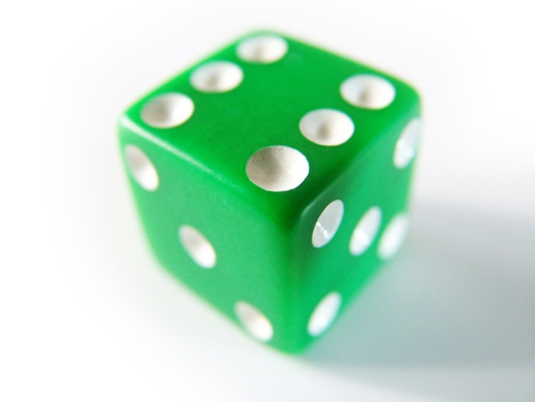

- What is the probability that it comes to rest on a number greater than 2?
- Which is more likely:
- rolling more that 3 on this die, or
- picking a day of the week at random that begins with the letter S.

Judging the evidence for Mathematics: Expressions and Formulae (National 4)

Outcomes | Assessment standards | Judging the evidence | Meeting the standard using this sample assessment
1 Use mathematical operational skills linked to expressions and formulae by: | 1.1 Applying algebraic skills to manipulating expressions and working with formulae | At least half of the main points of process and accuracy associated with the sub-skills in this assessment standard have been successfully demonstrated. | Question 1: using the distributive law in an expression with a numerical common factor to produce a sum of terms.  Question 2: factorising a sum of terms with a numerical common factor.  Question 3: simplifying an expression which has more than one variable.  Question 4: evaluating an expression or a formula which has more than one variable.  Question 5: extending a straightforward number or diagrammatic pattern and determining its formula.  Question 6: calculating the gradient of a straight line from horizontal and vertical distances.
 | 1.2 Applying geometric skills to circumference, area and volume | At least half of the main points of process and accuracy associated with the sub-skills in this assessment standard have been successfully demonstrated. | Question 7: calculating the circumference and area of a circle.  Question 8: calculating the area of a parallelogram, kite, trapezium.  Question 9: investigating the surface of a prism.  Question 10: calculating the volume of a prism.  Question 11: using rotational symmetry.
 | 1.3 Applying statistical skills to representing and analysing data and to probability | At least half of the main points of process and accuracy associated with the sub-skills in this assessment standard have been successfully demonstrated. | Question 12: constructing a frequency table with class intervals from raw data.  Question 13: determining statistics of a data set; interpreting calculated statistics.  Question 14: representing raw data in a pie chart.  Question 15: using probability.
2 Use mathematical reasoning skills linked to expressions and formulae by: | 2.1 Interpreting a situation where mathematics can be used and identifying a valid strategy | This assessment standard should be achieved on at least one occasion. | Questions 4 and 7
 | 2.2 Explaining a solution and/or relating it to context | This assessment standard should be achieved on at least one occasion. | Questions 12 and 15

Appendix 2: Guidance on judging evidence

Main points which demonstrate the achievement of the assessment standards

Points of reasoning are marked # in the table.

Question | Main points of expected responses
1 (a)  (b) | •¹ multiply out brackets  •² multiply out brackets  •³ collect like terms | •¹ 15x – 5  •² 24q + 8 + 3q  •³ 27q + 8
2 | •¹ identify common factor  •² factorise expression | •¹ 4  •² 4(y + 6)
3 | •¹ collect like terms | •¹ 8w + s
4 (a)  (b)  (c) | •¹ substitute into expression  •² evaluate expression  •³ substitute into expression  •⁴ evaluate expression  # 2.1 valid strategy | •¹ 5 × 4 – 4 × 3  •² 8  •³ 5·5 × 20 + 2·5 × 16  •⁴ (£)150  # 2.1  240 = 5·5 × H + 2·5 × 16  5·5 H = 240  H = 30 (hours)
5 (a)  (b) | •¹ extend sequence  •² complete table  •³ begin to find formula  •⁴ correct formula | •¹ 10, 13, 16  •² 37  •³ ×3  •⁴ B = 3S + 1
6 | •¹ calculate gradient | •¹ or 0·491…
Outcome 1.1 | Need 8 out of 15 to pass.
7 (a)  (b)  (c) | •¹ circumference of circle  •² calculate circumference  •³ area of circle  •⁴ calculate the area of circle  # 2.1 valid strategy | •¹ π × 51  •² 160·2 or equivalent  •³ π × 25·5²  •⁴ 2042·82 or equivalent  # 2.1 1000 ÷ 160.2 = 6.2..  6 hula hoops
8 | •¹ area of parallelogram  •² area of parallelogram | •¹ 1.3 × 2.4  •² 3.12 (m²)
9 | •¹ calculate all 3 areas  •² find total area | •¹ 16200, 2250, 4500  •² 45900 (cm²)
10 | •¹ volume of cylinder  •² correct answer | •¹ 13 × 26·7  •² 347.1 m³
11 | •¹ correct rotation | •¹ correct rotation
Outcome 1.2 | Need 6 out of 11 to pass
12 | •¹ correct intervals and tally marks  •² all frequencies correct  # 2.2 correct statement with reason | •^{1 and 2}
  Score | Tally | Frequency
  30 – 39 | ⎪ | 1
  40 – 49 | ⎪⎪⎪ | 3
  50 – 59 | ⎪⎪ | 2
  60 – 69 | ⎪⎪⎪⎪ | 5
  70 – 79 | ⎪⎪⎪ | 3
   |  | (Total = 14)
13 (a)  (b) | •¹ calculate total age  •² calculate mean  •³ find range | •¹ 182  •² 22.75  •³ 20
14 | •¹ calculate angles in pie chart  •² construct pie chart  •³ label sections | •¹ 60º, 180º, 120º  •² pie chart drawn with angles correct to ±2 degrees  •³ labels ‘cat’, ‘dog’, ’none’
15 | •¹ state probability  # 2.2 correct statement with reason | •¹  # 2.2 rolling more that 3 on this die with reason
Outcome 1.3 | Need 5 out 9 to pass
Outcome 2.1 | Need 1 out 2 to pass
Outcome 2.2 | Need 1 out 2 to pass

